Post Out Going Payment with TDS (at Payment)

S.NO. : 01- FI-AP- 11

TRANSACTION CODE : F – 53

ACCESS PATH : SAP Easy Access Accounting Financial
Accounting Accounts Payable Document
Entry Out going payment Post

We get “ Post Out Going Payment” Header data” screen ;

Required Fields:

Document date : To be entered
Account : To be entered (Vendor A/c Number)
Account Type : Default
Standard Ois : Default Ticked
Account : To be entered (Bank A/c Number)
Posting date : Default
Amount : Net amount excluding the TDS amount to be entered
Bank Charges : To be entered

Rest all other fields viz, Doc Type, Period, Companycode,Currency/Rate are default after they are entered for the first time.

We get the Screen “Post Out Going Payment - Header Data“ incorporating the above mentioned required fields as under;

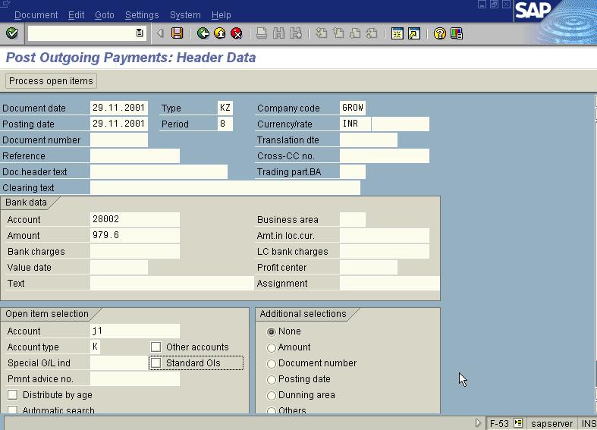
In the above screen take the net amount

Press button

Now we get “ Post Out Going Payment – Process Open Items” screen as below
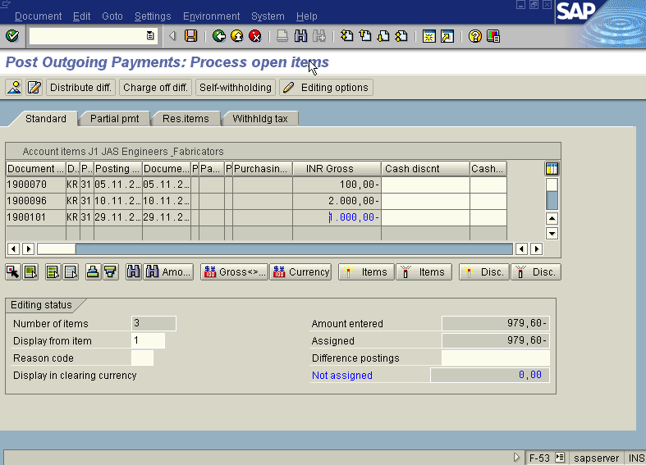

In the above “ Post Out Going Payment – Process Open Items” screen

In the above case there is only one open item to process and the Not assigned field is Zero so press save icon. And take a note of the document number.

If there are more process open item on the above screen follow the step as below:

(Press icon (Select all) so that all items will be highlighted in blue.

Press icon (Deactivate items) so that all items will be highlighted in blue turns to normal in black

Now use the Scroll bar on the above “ Post Out Going Payment – Process Open Items” screen till you find your Invoice on the above Screen. Then once we have found the Invoice we wanted to post, Just just double click with the mouse on the Amount field eg. 979.60 in this case so the amount highlighted will turn to blue colour and the Not assigned field will turn to Zero . Here we should keep in mind that this Not assigned field has to be brought to zero to make the posting.)

Press Save button

Take a note of the document number ; 1500215

This is the stage where “Post Out Going payment” stage is complete

The document can be seen from Document Display from the top left hand side of the main screen “post out going payment - Header Data“ OR from Transaction code FB- 03 .The Document overview screen will be displayed as under showing the entries.
